Segments
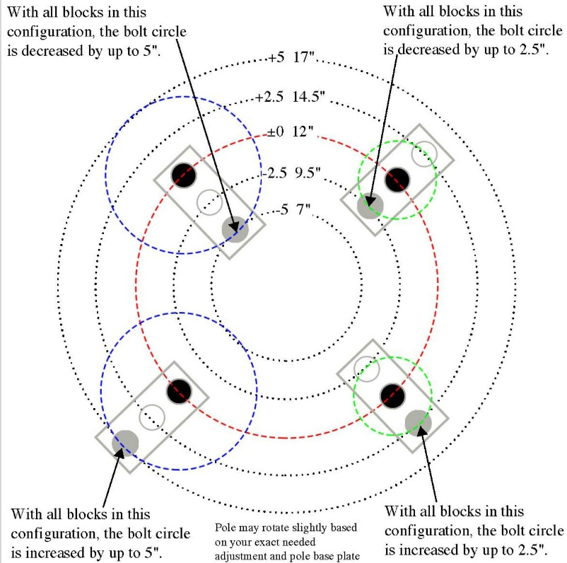
- Anchor Bolts segment
input
- Nb = total number of anchor bolts
- db = nominal anchor bolt diameter (in)
- dh = anchor bolt hole diameter (in)
- rb = anchor bolt circle radius (ft or in)
- αb = start angle of first anchor bolt (deg)
- θ_{seg} = segment angle (deg), if bolts are checked by segment
- ns = number of segments
- t_{bp} = base plate thickness (in)
- fy = bolt yield strength, if needed
- fu = bolt ultimate strength, if needed
- Tu = design uplift/tension demand on one bolt or bolt group
- Vu = design shear demand on one bolt or bolt group
- φ = resistance factor, if your software includes strength check
- e = edge distance from hole to plate edge, if required
- s = bolt spacing, if user enters directly
- nbs = number of bolts per segment

output
- Bolt cross-sectional area
If we consider nominal diameter
$$A_{b}= \frac{πd_{b}^{2}}{4} \left({inch}^{2}\right)$$
2) Hole area
$$A_{h}= \frac{πd_{h}^{2}}{4}$$
3) Bolt angular spacing around full circle
$${Δθ}_{b}= \frac{360}{N_{b}}$$
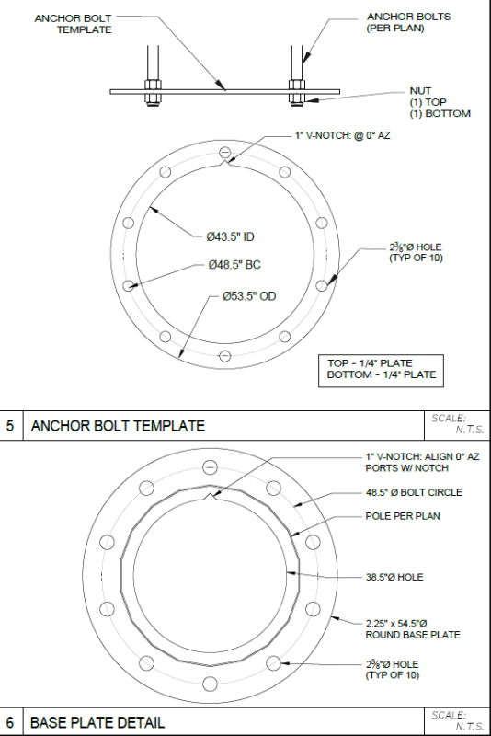
4) Angle of each bolt
For bolt $i$:
$$θ_{i}= α_{b}+\left(i-1\right)∆θ_{b}$$
5) Coordinates of each anchor bolt
If on bolt circle radius $r_{b}$:
$$x_{i}= r_{b}cosθ_{i}$$
$$y_{i}= r_{b}sinθ_{i}$$

6) Arc spacing between adjacent bolts
$$S_{arc}=r_{b}∆θ_{b} \frac{π}{180}$$
7) Chord spacing between adjacent bolts
This is usually more practical than arc spacing:
$$S_{chord}={2r}_{b}\sin{\frac{∆θ_{b}}{2}}$$
8) Number of bolts per segment

$$n_{bs}= \frac{N_{b}}{n_{s}}$$
This should be an integer.
If not, the software should flag a warning.

9) Bolt hole clear edge distance check
If the hole is located between plate edges, the minimum clear edge distance can be written as:
$$e_{clear}=e- \frac{d_{h}}{2}$$
10) Tension demand per bolt
If total uplift is shared equally:
$$T_{bolt}= \frac{T_{u}}{N_{b}}$$
$$T_{bolt}= \frac{T_{u}}{N_{effi}}$$
If only some bolts resist uplift we are using the last equation where $N_{effi}=effictive number of bolts in tension$.

11) Shear demand per bolt
If total shear is shared equally:
$$V_{bolt}= \frac{V_{u}}{N_{b}}$$

12) Tensile capacity of one bolt
Basic form:
$$P_{nt}=A_{b}F_{nt}$$
or design strength:
$$∅P_{nt}={∅A}_{b}F_{nt}$$
If we use ultimate strength:
$$∅P_{nt}={∅A}_{b}F_{u}$$
13) Shear capacity of one bolt
$$V_{n}=A_{b}F_{nv}$$
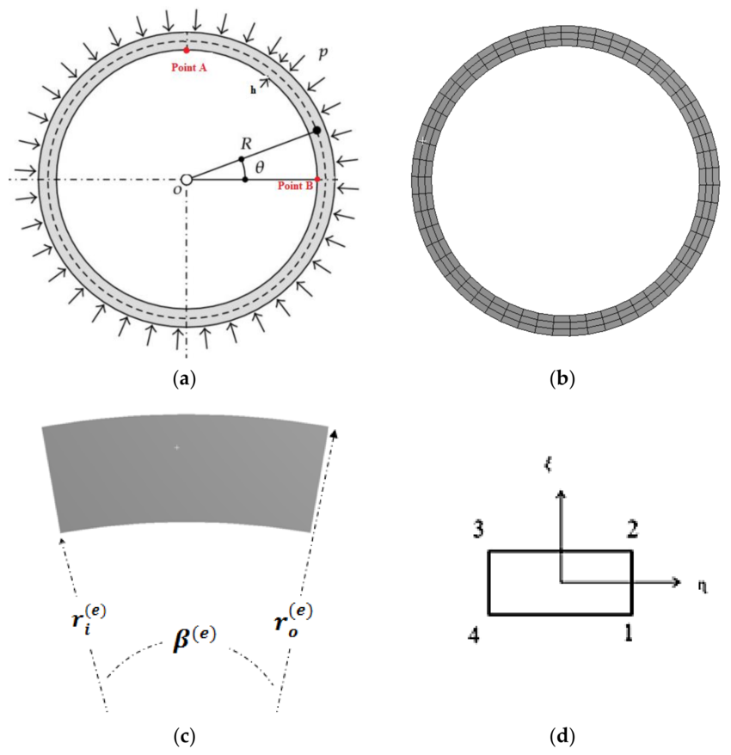
or design strength:
$${∅V}_{n}={∅A}_{b}F_{nv}$$
14) Interaction check for combined tension and shear
A simple software form can be:
$Utilization= \frac{T_{bolt}}{∅P_{nt}}$ + $\frac{V_{bolt}}{{∅V}_{n}}$
Pass if:
$$Utilization≤1.0$$
- Base plate segment
input
- Dbp = base plate diameter (ft or in)
- Ro = base plate outside radius
- Ri = base plate inside radius
- θ = base plate segment angle (deg)
- t = base plate thickness (in)
- n = number of base plate segments
- rs = steel unit weight = 490 pcf
- Nh = number of anchor bolt holes in one segment
- dh = diameter of anchor bolt hole
- α = start angle of segment (deg), if you want location in plan
- rb = bolt circle radius, if bolt layout is needed
Output
- Gross area, $A_{g}$
$$A_{g}= \frac{θ}{360}π \left(R_{0}^{2}- R_{i}^{2}\right)$$
- Net area, $A_{n}$
$$A_{n}=A_{g}- N_{h}\left( \frac{πd_{h}^{2}}{4} \right)\frac{1}{144}$$

- Volume, $V$
$$V= A_{g}\left(\frac{t}{12}\right)$$

- Weight per segment, $W_{bp}$
$$W_{bp}= A_{g}( \frac{t}{12}) ( \frac{r_{s}}{1000}$$
- Total weight, $W_{bp,total}$
$$W_{bp,total}=n .W_{bp}$$
- Outer arc length, $L_{o}$
$$L_{o} =R_{0} .θ_{r}$$
- Inner arc length, $L_{i}$
$$L_{i} =R_{i} .θ_{r}$$
$$θ_{r}= θ\left(\frac{π}{180}\right)$$
- Radial width, $b$
$$b =R_{0}-R_{i}$$
- Centroid radius, $\overset{ˉ}{r}$
For one segment, the centroid lies on the segment centerline:
$$\overset{ˉ}{r} = \frac{4\sin\left(\frac{θr​}{2}\right)}{{3θ}_{s}} x \frac{R_{0}^{3}- R_{i}^{3}}{R_{0}^{2}- R_{i}^{2}}$$
$\overset{ˉ}{r}$= radial location of centroid from center
$θ_{s}$= segment angle (in radians)

- Centroid angle of segment
$$β= ∝ + \frac{θ}{2}$$
$β$= centroid angle (location of centroid in angular direction)
$α$= starting angle of the segment
$θ$= segment angle
Centroid coordinates, $\left(x_{c} , y_{c}\right)$

$$x_{c}= \overset{ˉ}{r}cosβ$$
$$y_{c}= \overset{ˉ}{r}sinβ$$

